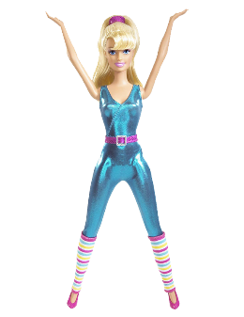
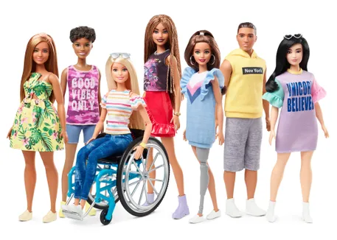
CSI TOY STORY:
A Toy Design Challenge

Primary objective
Using a power supply created in electronics class, your group will either:
- repurpose an existing toy and rebrand it
or
- create a new toy and brand it

Breakdown of Requirements for Each Class

English
- Clear, understandable instructions for usage. Wording and concept developed by all group members -- layout developed in Adobe Illustrator by digital media students.
- Marketing plan.
- Elevator pitch.

Digital Media
- Rebrand the existing toy or game to give it a fresh, appealing image for your target market.
- Create the logo in Adobe Illustrator.
- Create clear usage instructions with illustrations in Adobe Illustrator.
- Modify the cosmetic look of the original toy to make it cohesive with the marketing/rebranding strategy.
- Creating packaging for the toy is highly encouraged.
- Digital Media students who are working solo will not be expected to create packaging, but still should address the cosmetic look of the toy.

Electronics
Build your own power supply with the following requirements:
- 0-12 volt output
- Potentiometer that can be adjusted easily from inside/outside the project
- Packaged properly in the project. (Safety precautions must be followed)
- Ability to power the toy or game that is created.

Important Dates/ Work Days
- Full work days Monday March 18- Friday March 22
- Full work day Wednesday, March 26
- Trade Show: Thursday, March 27th
*Work times subject to change based on productivity.

