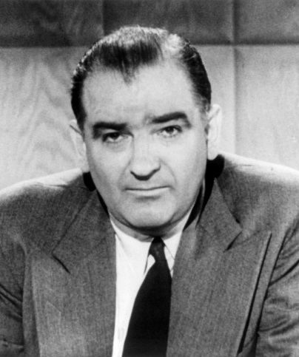
Joseph McCarthy
Senator from Wisconsin
Served from 1947-1957 (the year of his death)

Demagogue - a leader in a democracy who gains popularity by exploiting prejudice and ignorance among the common people, whipping up the passions of the crowd and shutting down reasoned deliberation.

McCarthyism is the practice of making accusations of subversion or treason without proper regard for evidence. It also means "the practice of making unfair allegations or using unfair investigative techniques, especially in order to restrict dissent or political criticism." The term has its origins in the period in the United States known as the (second) Red Scare, lasting roughly from 1950 to 1956

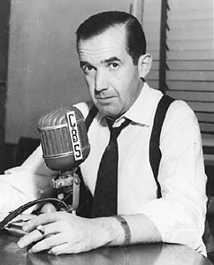
Edward R. Murrow
American Broadcast journalist – a pioneer of television news broadcasting. Produced a series of reports that helped lead to the censure of Senator Joseph McCarthy.

Censure - an expression of strong disapproval or harsh criticism.

Arthur Miller
(October 17, 1915 – February 10, 2005) was an American playwright, essayist, and prominent figure in twentieth-century American theatre. Among his most popular plays are All My Sons (1947), Death of a Salesman(1949), The Crucible (1953). The drama Death of a Salesman is often numbered on the short list of finest American plays in the 20th century.
Miller was often in the public eye, particularly during the late 1940s, 1950s and early 1960s. During this time, he was awarded the Pulitzer Prize for Drama, testified before theHouse Un-American Activities Committee, and was married to Marilyn Monroe.

