Of Mice and Men by John Steinbeck – Literary Analysis NOTES
Foreshadowing: an advance sign or warning of what is to come in the future. Foreshadowing is used as a literary device to tease readers about plot turns that will occur later in the story.
Point of View (POV): (in fictional writing) the narrator's position in relation to the story being told
1st Person POV: the story is narrated by one character at a time. This character may be speaking about him or herself or sharing events that he or she is experiencing.
3rd Person POV:
3rd Person Limited:

3rd Person Omniscient:

3rd Person Objective:

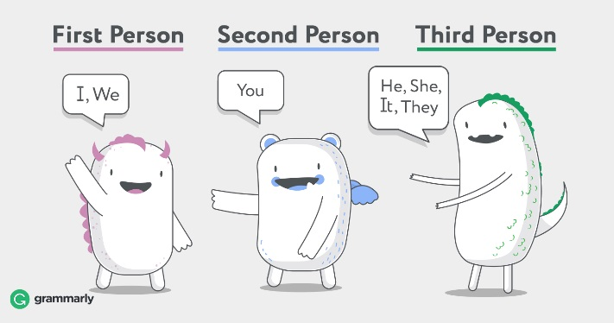
Symbiosis: interaction between two different organisms living in close physical association, typically to the advantage of both.
Symbiotic relationships: a special type of interaction between species. Sometimes beneficial, sometimes harmful, these relationships are essential to many organisms and ecosystems, and they provide a balance that can only be achieved by working together.
Two organisms that live together in symbiosis may have one of three kinds of relationships: mutualism, commensalism, or parasitism.
Mutualism: a long-term relationship between individuals (in biology… of different species) where both individuals benefit
Commensalism: a relationship between two living organisms where one benefits and the other is not significantly harmed or helped.
Parasitism: a relationship where one organism, the parasite, lives on or in another organism, the host, causing it some harm, and is adapted to this way of life.

