Off the Grid
Surviving an "American Blackout" or Zombie Apocalypse
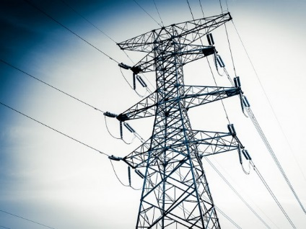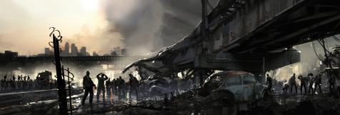
Mission: Create a company that designs, creates, and promotes an alternative-energy compound for the consumer to survive off the grid. Your final project will be showcased at a trade show on November 13th, 2015.
Keep in mind: Preparedness is the key to survival. The company who addresses a variety of potential concerns will be sought after - consider shelter, sustainable water, food, power source(s), etc.
Deliverables for Trade Show:
- Company/product name and logo
- Branding of product
- Print ad/commercial/PSA/animation
- Physical 3D Model of compound with descriptions of features
- Functioning feature of compound (security system, power, etc.)
***Additional requirements for English, math, and electives will be addressed in classes***

Resources: Visit www.mrfeldkamp.com for information on alternative energy options to consider

Off the Grid
Project Timeline
Week One:
- Project Overview
- EMPATHIZE PHASE
  - Interview Questions/Responses
Week Two:
- DEFINE PHASE
  - Based on your empathy work, identify a genuine need/needs of authentic consumers. Ultimately, you will design something to meet these needs.
  - Submit the challenge statement to your English Teacher
  - Alternative Energy Options Lecture (Feldkamp & Spry)
- IDEATE PHASE
  - Brainstorming videos
  - Generate a large quantity of diverse solutions, allowing you to step beyond the obvious and explore a range of ideas
- PROTOTYPE PHASE
  - Transform your ideas into a physical form so that you can experience and interact with them
  - Learn and develop more empathy
Week Three:
- Continue PROTOTYPE PHASE
  - Share feedback
- TEST PHASE
  - Try out final products
  - Use observations and feedback to refine prototypes
  - Learn more about the user
  - Refine your original point of view
Week Four:
- Trade show display tips/suggestions
- Trade Show on 11/13/15

