Your Name: __________________________ Novel Title: ________________________
Group Members: Author: ______________________

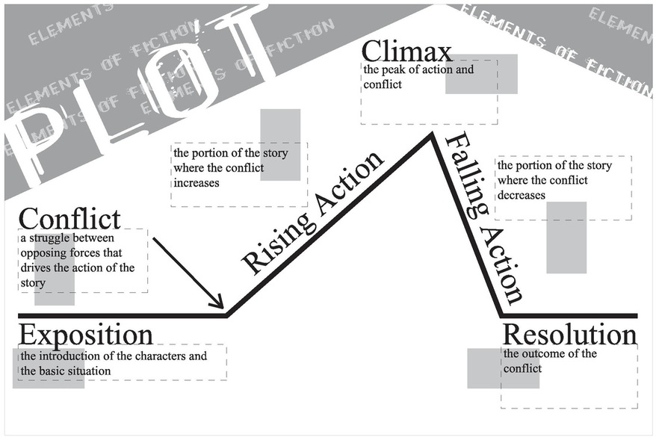
With attention to detail and specificity, describe each of the following plot elements within your novel:
Exposition:

Conflict:
Rising Action:

Climax:

Falling Action:

Resolution:

