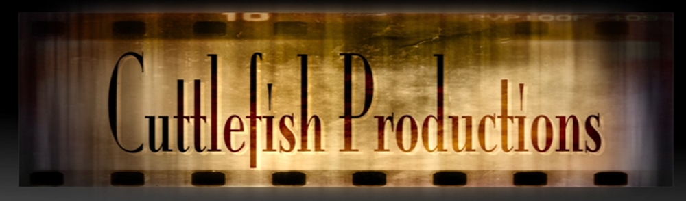
…in conjunction with MrFeldkamp.com and in conjunction with CSIJenkins.weebly.com
Project Plan
Author:
Original Creation Date:
Last Revised:
Version:

Project Overview

(This section should provide an impression of your project, including the highest level milestones. Delete this text and type your words in this area)

Project Goals and Objectives

Write at least THREE goals that you have for this project

Researchable Questions:

Minimum of THREE
Checklist of your Potential Research Questions:
1) Is the research question something I/others care about? Is it arguable?
2) Is the research question a new spin on an old idea, or does it solve a problem?
3) Is it too broad or too narrow?
4) Is the research question researchable within the given time frame and location?
5) What information is needed?

--or for more technical based research:

1) Define or measure a specific fact or gather facts about a specific phenomenon.
2) Match facts and theory.
3) Evaluate and compare two theories, models, or hypotheses.
4) Prove that a certain method is more effective than other methods.

Projected Budget

(Optional)
Define the project budget and insert it here:

Milestones

The following represent key project milestones, with estimated completion dates:

Milestone Estimated Completion Date

Communications Plan

Disseminating knowledge about the project is essential to the project’s success.

This plan provides a framework for informing, involving, and obtaining buy-in.
In other words, how will you PRESENT your project?

Audience This project is intended for the following audiences:

